T-1200S
Drilling and Tapping Machining Center
Technical Agreement
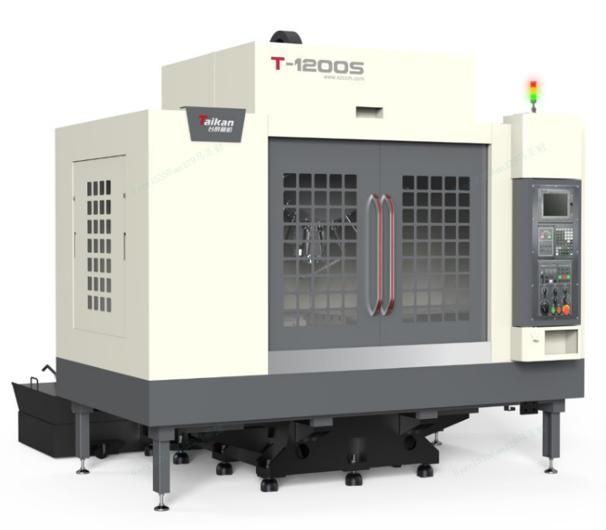
(This figure is for reference only)
- Technical description.
- Equipment technical description
T-1200S Drilling and Tapping Machining Center has a large stroke design that can meet customers' processing requirements for large-size parts. The X, Y, and Z axis screws all use precision ball screws, and the three-axis guides use precision linear guides; the three axes use absolute servo motors; the spindle uses a precision-grade spindle, and through a direct-connected transmission structure, the standard speed is 20,000 rpm; the cast iron uses the Meehanite casting process and is fully heat-treated to eliminate internal stress. This machine tool is mainly used for light processing of small and medium-sized boxes, frames, plate parts, disc parts, and shells in general, 5G and other industries.
- The widened and enlarged heavy-duty base, while lowering the center of gravity, can resist torsion and damping, and effectively move the cutting vibration to the non-cutting area;
- The spindle motor and spindle are directly driven to reduce the error of high-speed tapping. The high output force characteristics can be greatly utilized in high-speed and efficient processing;
- The high-speed spindle has a fast response speed, and the use of ceramic ball bearings greatly extends the service life of the spindle;
- The Z-axis optimization improves the rigidity and greatly improves the acceleration of the Z-axis, reducing the idle stroke running time;
- The machine tool has a large tilt chip removal angle, the machine tool flushes the chips quickly, and the machine tool is equipped with a standard high-power water pump to quickly flush the chips and speed up the return speed of the cutting fluid;
- 21T high-speed servo tool change, PLC tool change is optimally optimized, shortens the tool change time, is fast and stable, and reduces non-processing time;
- It has high-speed rigid tapping;
- By loading a high-speed PLC engine, the response speed is improved, the cycle is shortened, the processing detail parameters are optimized, the smoothness of the feed is improved, and the processing effect is improved;
- Working conditions
(1) Power supply: Three-phase AC, 380V ± 5%, 50Hz ± 1Hz. Main power cable and grounding wire: 6 mm² (for lengths up to 10 m) / 10 mm² (for lengths above 10 m).
(2) Ambient temperature: The ambient temperature should be maintained between 17°C and 25°C. If the machining tolerance is not stringent, the temperature can be relaxed to 5°C to 40°C. Storage and transportation temperature range: -20°C to 60°C.
(3) Room temperature fluctuation: The temperature fluctuation in the surrounding area should be within ±2°C over a 24-hour period.
(4) Relative humidity: Less than 75% (without condensation).
(5) Altitude: Below 1000 meters.
(6) Vibration: Below 0.2G;
(7) Foundation requirements: Load-bearing capacity of 32 kN/m² or higher.
(8) Keep away from light sources, vibration sources, and heat sources. Avoid proximity to high-frequency motors, discharge motors, welding machines, etc., to prevent electrical interference that could cause faults in the CNC system.

- Equipment parameters and configuration
2.1 Basic parameters
Item |  |  | Unit | Parameter | Remark
Travel | Table travel (X axis) |  | mm | 1200
Travel | Saddle travel (Y axis) |  | mm | 550
Travel | Headstock travel (Z axis) |  | mm | 450
Travel | Distance from spindle end face to worktable surface |  | mm | 125~575
Travel | Distance from spindle center to column guide |  | mm | 632
Worktable | Table size |  | mm | 1300*550
Worktable | Max. load |  | kg | 500
Worktable | T-shaped slot (number of slots-slot width*spacing) |  | mm | 5-18*100
Spindle | Motor power (rated/short time) |  | kW | 3.7/5.5
Spindle | Spindle torque (rated/short time) |  | N.m | 14.1/21
Spindle | Spindle motor speed |  | rpm | 20-20000
Spindle | Spindle diameter |  | mm | Ф100
Spindle | Spindle taper |  | / | BT30
Guide | X-axis |  | / | 35
Guide | Y axis |  | / | 35
Guide | Z axis |  | / | 45
Drive | Lead screw X/Y/Z |  | mm | X：40/12 Y: 40/12  Z: 40/12
Drive | Servo motor power X/Y/Z |  | kW | 2.0/2.0/3.0
Speed | Cutting feed speed range |  | mm/min | 1-15000
Speed | X, Y, Z axis rapid speed |  | m/min | 36/36/36
Precision | Positioning accuracy (X/Y/Z) |  | mm | 0.01 | GB/T 18400.4  (Full travel)
Precision | Repeatability(X/Y/Z) |  | mm | 0.006 | GB/T 18400.4  (Full travel)
Tool magazine | Tool magazine capacity |  | T | 21
Tool magazine | Max. tool weight |  | kg | 3
Tool magazine | Max. tool length |  | mm | 250
Tool magazine | Max. tool diameter (full /adjacent empty) |  | mm | Ф60/Ф80
Other | CNC system |  |  | Mitsubishi M80VB
Other | Air supply | Flow | L/min | ≥200（ANR）
Other | Air supply | Air pressure | MPa | 0.6-0.8
Other | Total power capacity |  | kVA | 15
Other | Coolant tank volume |  | L | 330
Other | Machine dimensions |  | mm | 2850*3300*2850 (highest point of Z-axis drag chain) | Corresponding to X*Y*Z axis
Other | Machine weight (approx.) |  | kg | 5000
#: The dimensions of the machine are subject to change without prior notice due to configuration.

2.2 Customer-choosing configuration
NO. | Item | Quantity | Remark
1
2
3

2.3 Equipment standard configuration
NO. | Item | Quantity | Remark
1 | Direct-drive spindle 24000rpm | 1
2 | Spindle motor 20000rpm | 1
3 | 21T servo tool magazine | 1
4 | Centralized automatic lubrication system | 1
5 | Explosion-proof work light | 1
6 | Three-color warning light | 1
7 | SD card | 1
8 | Fully sealed cover sheet metal protection | 1
9 | Pneumatic system | 1
10 | Random set of standard technical documents | 1 | Electronic file
11 | Mitsubishi M80VB system | 1
12 | Domestic tool magazine motor/drive | 1

- Brands of main parts of equipment
Main parts
No. | Part name | Brand | Remark
1 | Screw bearings | Germany FAG
2 | Ball screws | Taiwan PMI
3 | Spindle unit | Taikan | 24000 rpm
4 | Tool magazine | Taikan
5 | Main pneumatic components | SMC/CKD
6 | Spindle servo motor | Japan Mitsubishi | 20000 rpm
7 | Drive servo motor | Japan Mitsubishi
8 | CNC system | Japan Mitsubishi M80VB
9 | Lubrication device | BAOTN
Note: In case of supply shortage, products of other brands will be used instead, but the quality and grade are not lower than the listed configuration.

- Main Function List of the System (Some functions require specific host configurations to be implemented).
No. | Function | Description | Notes
1 | Maximum total control axis (servo axis + spindle + PLC axis) | 9
1 | Maximum control servo axes | 5
1 | Maximum control spindles | 2
2 | Simultaneous control axes | Max. 4 axes
3 | Display unit | 10.4-inch color touchscreen
4 | Program capacity | 2500KB (NC storage + NC storage 2)
5 | High-speed machining mode
6 | High-speed, high-precision control | Max 101 kBPM
7 | SSS control
8 | Tolerance control
9 | Minimum instruction unit to 0.0001 mm | System can set minimum instruction unit
10 | Imperial/metric conversion | Conversion of machine units
11 | Decimal input | Programming instruction data specification method
12 | Positioning
13 | Linear interpolation | Multi-axis or single-axis coordinated movement control function
14 | Circular interpolation | Circular machining function
15 | Spiral interpolation | Spiral machining function
16 | Polar coordinate interpolation
17 | Polar coordinates
18 | Automatic acceleration/deceleration control
19 | High-speed rigid tapping | Reduces rigid tapping time and errors
20 | Thread time constant switching
21 | Manual rapid feed
22 | JOG feed
23 | Incremental feed
24 | Handwheel feed
25 | Pause
26 | Background editing | Program editing while machining
27 | Calculation input
28 | Absolute, incremental setting | Programming instruction data specification method
29 | Screensaver
30 | Parameter guide
31 | Alarm guide
32 | Screenshot
33 | Status, clock, operation, edit, maintenance display
34 | Fault diagnosis | Check current machine fault status
35 | Multi-language display function | Multi-language switching display
36 | Input/output of machining programs, parameters, tool offsets, etc.
37 | Multiple connection interfaces, network port, USB transfer | USB (max 32GB)
38 | Digital, analog spindle available
39 | Spindle positioning | Stops spindle at a fixed point for tapping, tool change, etc.
40 | Spindle synchronization control
41 | Tool compensation | 400 groups
42 | Coordinate system | Basic: G52-G59, extended 48 coordinates
43 | Coordinate rotation | Rotate orthogonal coordinates for easier programming
44 | Plane selection | Use G17, G18, G19 commands to select the desired plane
45 | Reference point 1, 2, 3, 4 return
46 | Program segment skip selection | Skip program segments for more flexible operations
47 | Single program segment | Program can execute one segment at a time
48 | Dry run
49 | Mechanical lock
50 | Auxiliary function lock
51 | Graphic inspection
52 | Program restart | Restart after temporary interruption
53 | Manual insert, MDI insert, etc. | Insert during operation
54 | Rigid tapping retraction | Retraction during rigid tapping interruption
55 | Macro programming | Variable programming available
56 | Fixed cycle for hole processing | Fixed cycles for hole machining, e.g., deep-hole drilling
57 | Set external input mirror | Achieve symmetrical machining via setting or external trigger
58 | Arbitrary angle chamfering/corner R | Arbitrary angle chamfering/corner R
59 | Drawing size input | Input dimensions as per drawing, e.g., corner chamfer
60 | Programmable data input | Input of instruction program data such as parameters, tool offsets
61 | Automatic corner scaling | Control for automatic corner machining scaling
62 | Deceleration check | Check for deceleration stop position
63 | Programming guide
64 | Thread pitch, backlash compensation | Machine axis pitch and backlash compensation
65 | Arc radius error compensation
66 | Dynamic precision compensation | Smooth high-gain, dual feedback (closed-loop)
67 | Tool life management 1 | Tool life monitoring
68 | Tool life management 2 | Expanded tool life management
69 | Tool life management quantity | 200 tools
70 | Alarm stop for each machine group
71 | Data protection for each user level
72 | Stroke protection
73 | Interlock
74 | Operation history, data backup
75 | Custom API library
76 | MES interface library
77 | Power consumption calculation
78 | PLC position switch | PLC function, designed as needed
79 | PLC servo off
80 | PLC axis removal
81 | Wireless network (Wi-Fi)
82 | Operation history display function
83 | Expanded common variables III
84 | PLC support for ST language
85 | High-precision parameter adjustment function
86 | OMR-CC
87 | Drilling chip removal function
88 | Fixed cutting reduction mode for drilling
89 | QR code machining cycle
90 | Laser machining control | Requires laser interface module
Special Note: For more functions, please refer to the M80V series specification selection guide. Due to differences in machine configurations and designs, please refer to the agreement for ordering.

- Recommended Oils and Grease Chart (Refer to this chart according to the actual configuration of the equipment).
Lubricating Part |  | Quantity | Recommended Oil |  | Remarks
 |  | Quantity | Room temperature 10-40℃ | Room temperature 5-10℃ | Remarks
Guide rail screw | Oil lubrication | 2-4 L | Guide rail oil 68# | Guide rail oil 32# | 1. Please add oil when checking before daily work or when the warning appears.  2. Pay attention to changing oil at low temperature.  3. When using canned grease, the brand of canned grease must be consistent with the manufacturer of the oiler.
Guide rail screw | Oil lubrication | 0.7-0.8L | Lithium base grease 000#
Spindle screw cooler | Coolant cooler | 15-35L | BASF G48 antifreeze (no addition of any medium is allowed)） |  | 1. Please add antifreeze or oil when checking before daily work or when the warning appears.  2. Please change the oil at low temperature.
Spindle screw cooler | Oil Cooler | 20-40L | No. 10 Great Wall Spindle Oil | No. 5 Great Wall Spindle Oil
Motorized spindle | Oil and air lubrication | 2-4L | ENEOS SUPER MULPUS DX32 (Brand: VG32) |  | Please refuel during daily pre-work inspection or when a warning message appears.
Hydraulic station |  | 25-40L | Hydraulic oil HV32# | Hydraulic oil HV20# | 1. Check before work every day and replace with new oil every year.  2. Pay attention to replacing oil at low temperatures.
Booster cylinder |  | 0.1-0.2L | Hydraulic oil 32# | Hydraulic oil 20# | 1. Check before work every day, and add oil when the oil cup is only 1/3 full.  2. Pay attention to changing oil at low temperature
Cutting fluid |  | 100-400L | According to the workpiece material and processing conditions, select the appropriate cutting fluid (based on the actual tank capacity) |  | When the room temperature is below 5℃, please check whether the fuel tank is frozen before starting the machine.
Fourth axis |  | 0.8-1L | Gear Oil 150# | Gear Oil 100# | 1. Check before work every day and replace the oil every six months.  2. Pay attention to replace the oil at low temperatures.
Tool changer arm system |  | 7 L | Gear Oil 100# | 80W-90 Antifreeze diesel engine oil | 1. Check before work every day, and replace the oil every 2400 working hours or every six months.  2. Pay attention to replace the oil at low temperatures.
Requirements:
A. The coolant must be water-soluble;
B. The coolant must be chemically stable and have lubricating properties;
C. Ensure that the coolant is not toxic to the human body;
D. Ensure that the coolant does not harden or swell items made of rubber and resin;
E. Use low-foam coolant;
F. If cutting fluid (oil) is not used for a long time, the protective cover needs to be maintained regularly.

- Others
1. Matters not covered in this agreement shall be resolved through negotiation between the two parties.
2. This agreement is an attachment to the contract and will take effect simultaneously with the contract after being signed by Party A and Party B.
3. This agreement is made in duplicate, with Party A and Party B each holding one copy.

